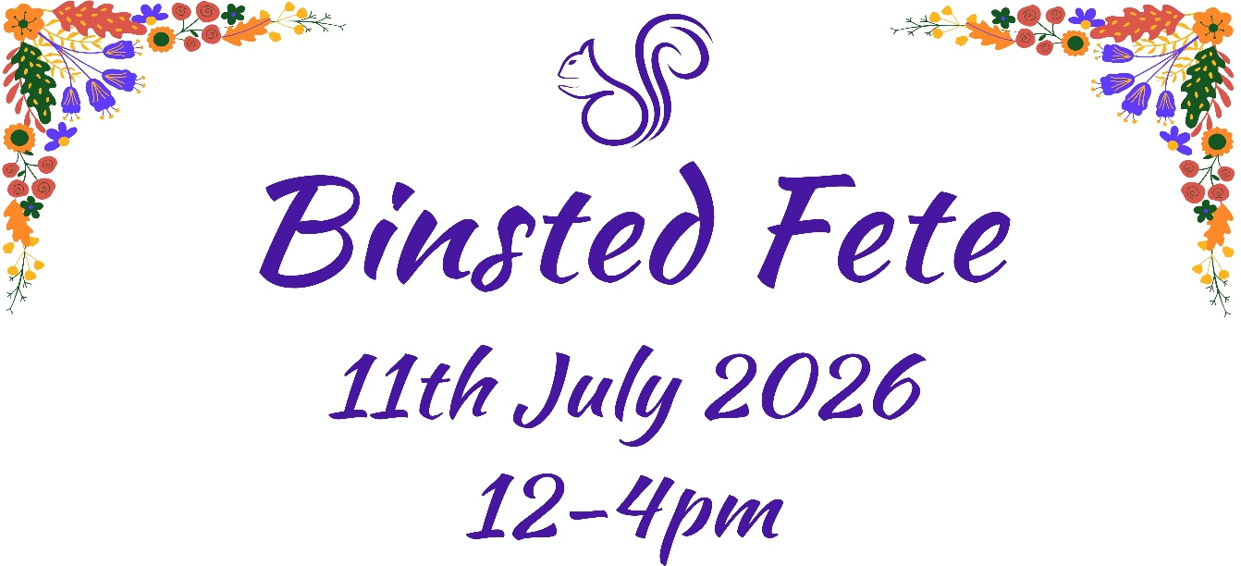

Flower & Produce Show – Entry Form.
This year’s Binsted Fete and Flower show encourages inclusion. There are no strict RHS guidelines to follow, we want everyone to feel they can enter with whatever flowers, fruits and vegetables they grow in their gardens. All classes are free to enter but donations towards the tent cost would be much appreciated.
We hope the children will enjoy making interesting and artistic entries in our Fruit, Vegetable and World Cup classes.

Our Categories. Please tick
- Best Roses. Any variety and amount of rose(s).
- All One Colour. A variety of flowers all in one colour theme.
- The Big One. The biggest, tallest or widest flower.
- Wonderful Fragrances. A Bouquet of smells.
- Wild and Beautiful. What can you find around Binsted?
- 5 Best Veggies. One of each home-grown vegetable.
- Fruit Salad. A display of home-grown fruits.
- World Cup. Colourful flags made from flowers or players
made from veggies? What can you make?

Please complete your entry form and email it to thebinstedfete@gmail.com Subject heading Flower Show entry. or bring it with you on the day. Donations can be made at the fete or direct to The Binsted Fete bank account, sort 30-99-09, ac, 00021109. Ref FS & surname.
We look forward to seeing everyone. The Binsted Fete. GU34 4PB.

